NAME:B.SRIMATHI
REG.NO : 192511448
COURSE CODE: ITA0502
SLOT:C
COURSE NAME : COMPUTER VISION
Comprehensive Analysis and Concept Mapping in Computer Vision & Image Processing

Q1. Real-World Scene to Digital Image Representation
The transformation of a physical, real-world three-dimensional scene into a digital two-dimensional numerical representation is the foundational pipeline of digital image processing. This complex transformation involves a series of optical, mechanical, electronic, and mathematical operations. The process begins at the physical layer, where light from an illumination source interacts with 3D objects in the scene, reflecting specific wavelengths and intensities based on surface properties. This light profile passes through imaging optics (lenses), which gather and focus the light rays onto a specialized light-sensitive electronic matrix—the image sensor (CCD/CMOS). The sensor converts photons into electrical currents, generating a continuous analog voltage map known as an analog image. To make this data readable by computers, it must undergo spatial discretization (Sampling) to form discrete M × N pixels, followed by intensity discretization (Quantization) to convert continuous voltages into bounded, discrete grayscale or color levels (0 to L-1). The result is a digital image represented mathematically as a matrix f(x, y). Once digitized, the data can be subjected to digital image processing techniques (enhancement and noise reduction), feature extraction (edges, corners), computer vision interpretation (object detection), and finally, automated real-world decisions or outputs. 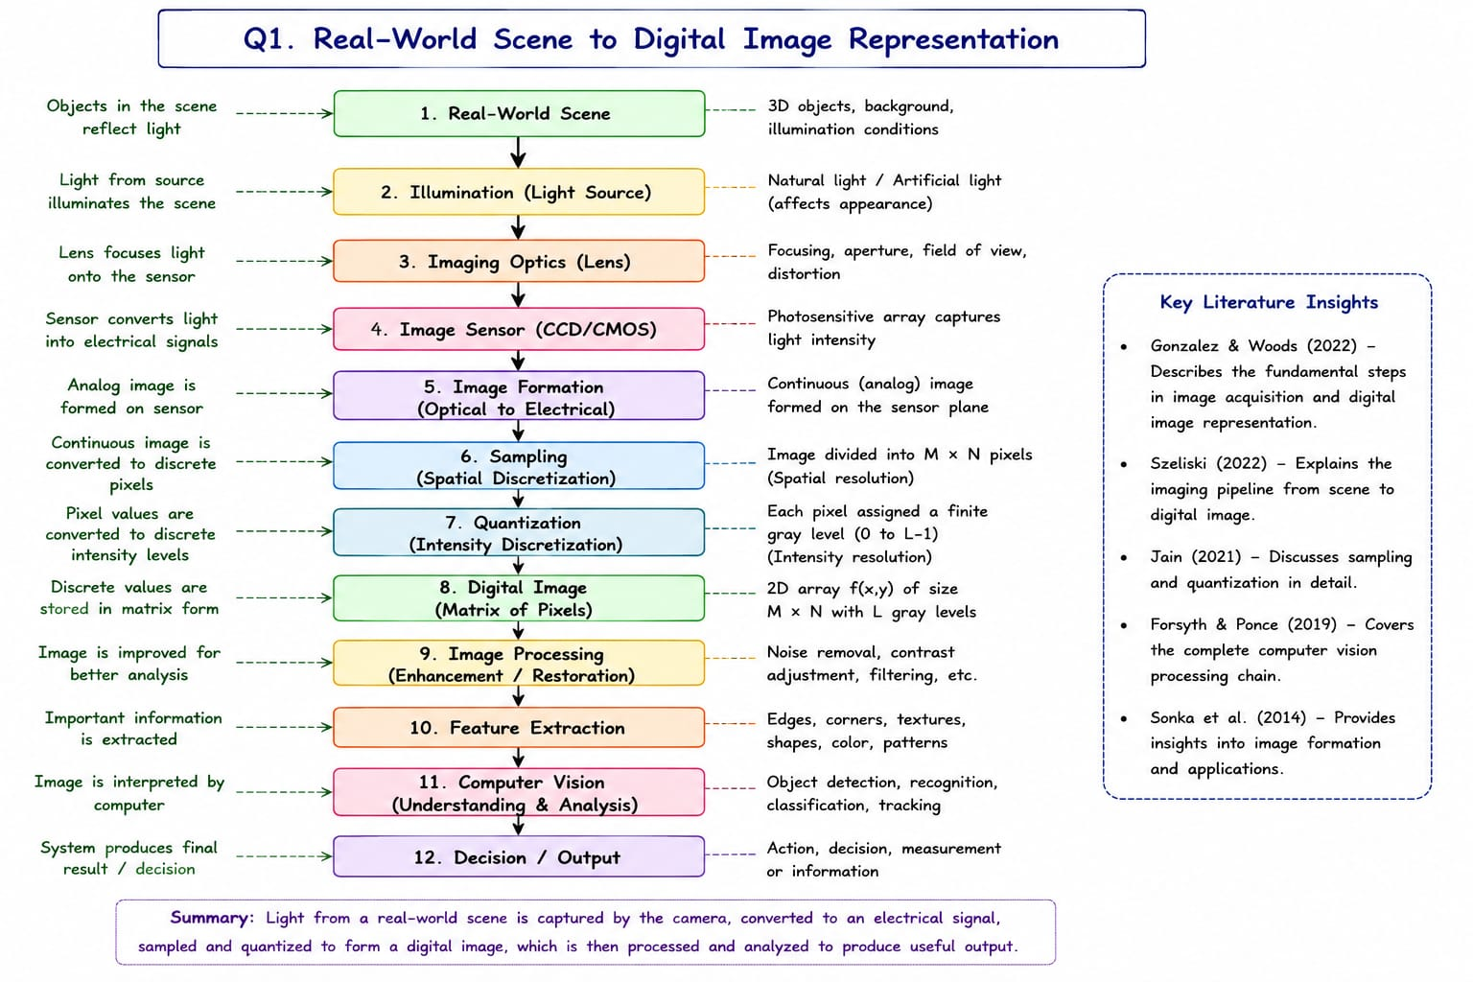

Concept Map Architecture (Q1)

Source Concept (Node A) | Linking Relationship | Target Concept (Node B)
Real-World Scene | illuminated by | Illumination (Light Source)
Illumination | reflects light off objects into | Imaging Optics (Lens)
Imaging Optics (Lens) | focuses gathered photons onto | Image Sensor (CCD/CMOS)
Image Sensor | converts light intensity to electrical signals via | Image Formation (Optical to Electrical)
Image Formation | produces continuous analog signal requiring | Sampling (Spatial Discretization)
Sampling | divides image into M x N pixels establishing | Quantization (Intensity Discretization)
Quantization | assigns finite gray levels (0 to L-1) creating | Digital Image f(x,y) Matrix
Digital Image Matrix | serves as fundamental input for | Image Processing (Enhancement/Restoration)
Image Processing | improves visual data quality for | Feature Extraction (Edges, Shapes)
Feature Extraction | provides structural tokens to | Computer Vision (Understanding & Analysis)
Computer Vision | interprets scene meaning to execute | Decision / Output (Action/Measurement)

Literature Insights & Evidence (Q1)
• Gonzalez & Woods (2022): Describe the fundamental steps in image acquisition and digital image representation.
• Szeliski (2022): Explains the imaging pipeline from scene to digital image.
• Jain (2021): Discusses sampling and quantization in detail.
• Forsyth & Ponce (2019): Covers the complete computer vision processing chain.
• Sonka et al. (2014): Provides insights into image formation and applications.

Q2. Computer Vision Processing Pipeline
A standard Computer Vision processing pipeline is organized hierarchically to transform raw visual data into intelligent, structured observations. The journey contains six core sequential modules: (1) Image Acquisition, which acts as the intake layer, capturing physical light patterns via sensors to produce a raw image file. The quality of this acquisition sets a ceiling for all downstream processes. (2) Preprocessing, which focuses on enhancement and noise reduction. Operations such as Gaussian filtering, histogram equalization, and geometric corrections ensure artifact removal and normalization. (3) Feature Extraction, which moves the data from pixel space to representation space. Here, raw arrays are reduced to key indicators like edges (Sobel/Canny), corner keypoints (SIFT/ORB), and textures. (4) Image Analysis, the level of semantic understanding where features are grouped and tracked to execute classification, object detection, bounding-box localization, and segmentation. (5) Interpretation, which incorporates high-level context and decision-support modeling, drawing cognitive inferences regarding scene events. (6) Decision Making / Output, which triggers concrete automated responses, control signals, alerts, or analytics data.
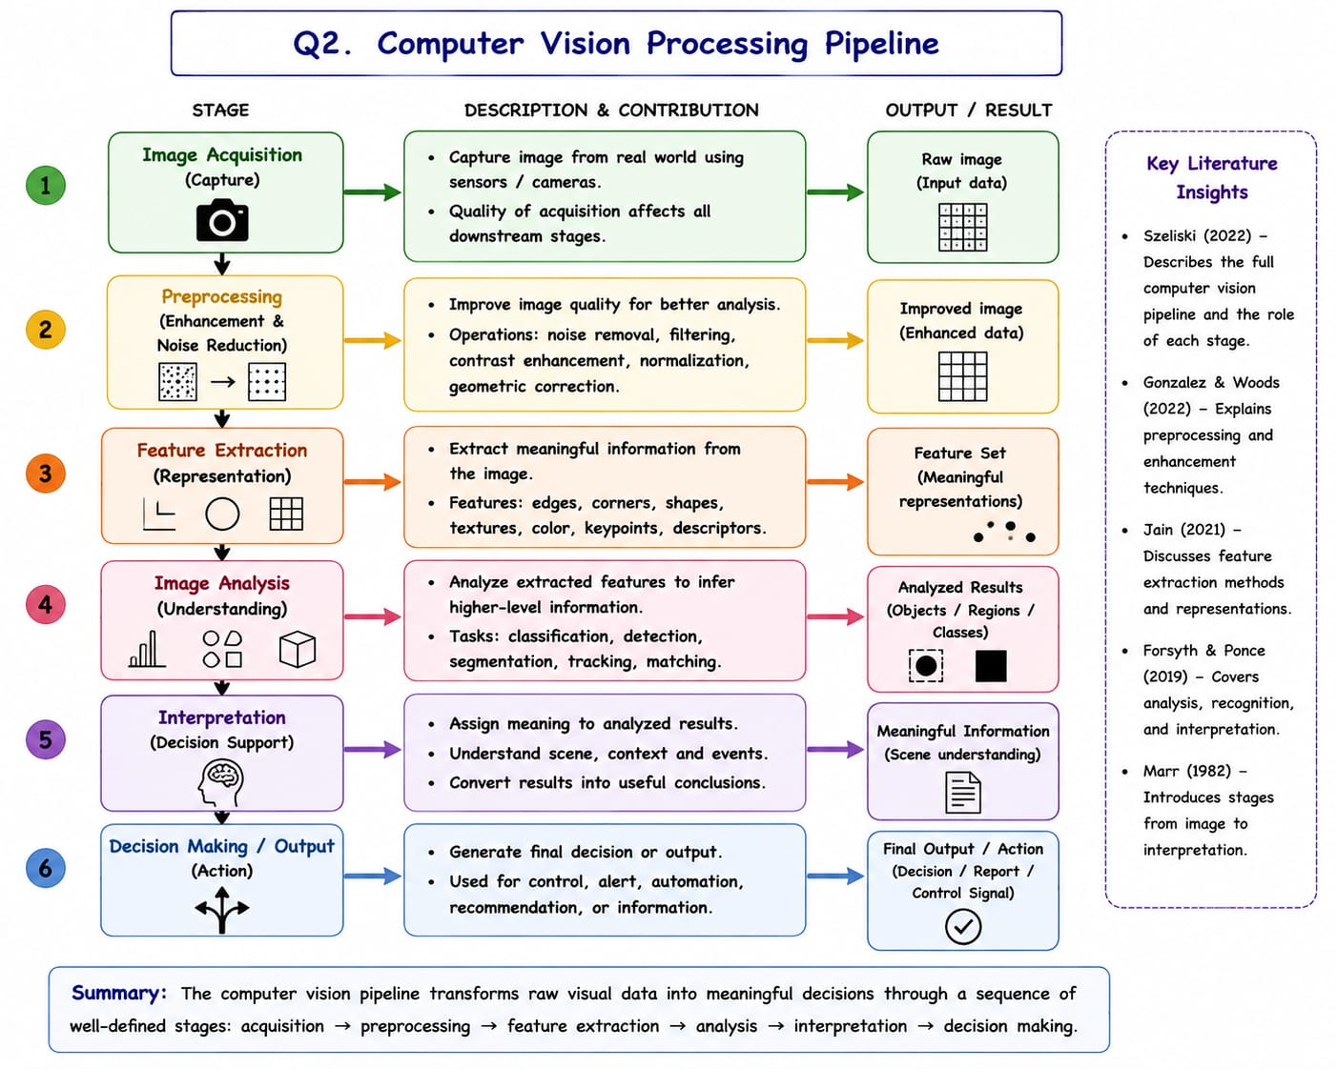

Computer Vision Processing Pipeline Diagram (Q2)

Processing Stage | Core Contribution & Description | Resulting Output / Product
1. Image Acquisition | Captures raw photons via sensor arrays; sets baseline quality. | Raw Image (Input Data Data Matrix)
2. Preprocessing | Applies noise removal, contrast adjustment, and normalization. | Improved Image (Enhanced Data)
3. Feature Extraction | Extracts primitive identifiers (edges, textures, geometric shapes). | Feature Set (Meaningful Representations)
4. Image Analysis | Executes high-level grouping, classification, detection, tracking, and segmentation. | Analyzed Results (Objects / Regions / Classes)
5. Interpretation | Contextualizes analyzed elements to assign meaning and understand scene context. | Meaningful Information (Scene understanding)
6. Decision Making / Output | Translates context into automation triggers, logs, reports, or control signals. | Final Output / Action (Decision / Report / Control Signal)

Literature Insights & Evidence (Q2)
• Szeliski (2022): Describes the full computer vision pipeline and the role of each stage.
• Gonzalez & Woods (2022): Explains preprocessing and enhancement techniques.
• Jain (2021): Discusses feature extraction methods and representations.
• Forsyth & Ponce (2019): Covers analysis, recognition, and interpretation.
• Marr (1982): Introduces stages from image to interpretation.
Q3. Image Resolution and Image Quality Relationships
Image resolution defines the granular detail a system can record, and it acts as a dual-component engine driving ultimate Image Quality. The first component, Spatial Resolution, refers to the number of pixels representing the image (dictated by sensor dimension M × N, pixel size, and sampling frequency). Higher spatial resolution renders fine details and better representation of small objects and edges. The second component, Intensity Resolution, refers to the number of intensity (brightness) levels. It is defined by the system's bit depth (e.g., 8-bit, 10-bit) and quantization levels (L = 2^b, where b = number of bits). Together, these resolutions determine the total information content and detail representation in an image. Perceived 'Image Quality' represents the perceived usefulness of the image for a specific application and depends on several interacting parameters: Sharpness (edge clarity), Contrast (difference between dark and bright regions), Signal to Noise Ratio (SNR, lower noise means better quality), Dynamic Range (range between min and max intensities), and Fidelity (how close the image is to the original scene). In real-world tasks, an appropriate balance is mandatory: medical imaging requires high spatial and intensity resolution for accurate diagnosis, remote sensing needs high spatial resolution for small object detection, while machine vision and surveillance demand optimal balances to support reliable inspection and real-time processing bandwidth constraints.
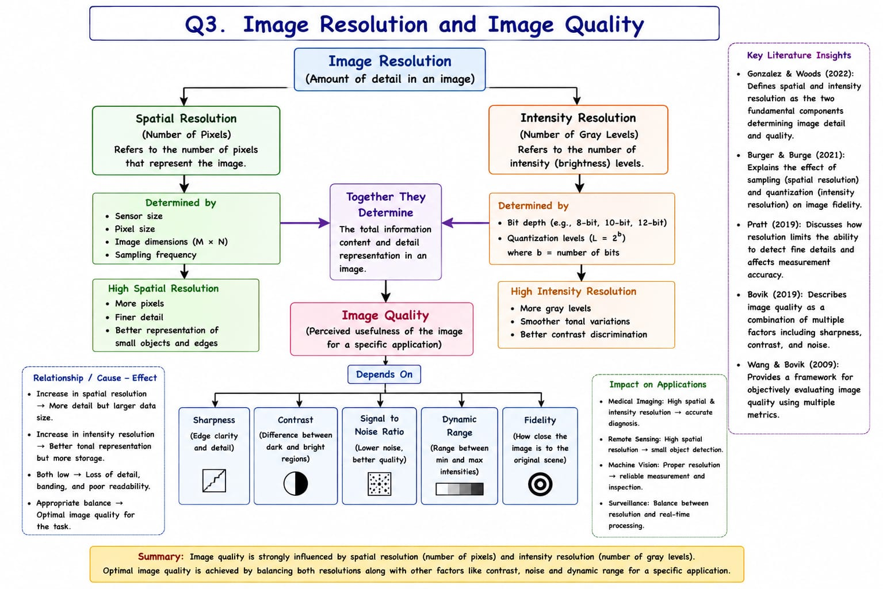
Image Resolution vs Quality Diagram (Q3)

Primary Resolution Axis | Determinants & Properties | Direct Impact on Perceived Quality
Spatial Resolution | Determined by sensor size, pixel size, dimensions (M x N), and sampling frequency. | High spatial resolution yields finer detail and crisp edge clarity.
Intensity Resolution | Determined by bit depth and quantization levels (L = 2^b). | High intensity resolution yields more gray levels, smoother tonal variations, and better contrast discrimination.
Image Quality Factors | Depends directly on Sharpness, Contrast, SNR, Dynamic Range, and Fidelity. | Dictates final performance impact across Application domains (Medical, Remote Sensing, Machine Vision, Surveillance).

Literature Insights & Evidence (Q3)
• Gonzalez & Woods (2022): Define spatial and intensity resolution as the two fundamental components determining image detail and quality.
• Burger & Burge (2021): Explains the effect of sampling (spatial resolution) and quantization (intensity resolution) on image fidelity.
• Pratt (2019): Discusses how resolution limits the ability to detect fine details and affects measurement accuracy.
• Bovik (2019): Describes image quality as a combination of multiple factors including sharpness, contrast, and noise.
• Wang & Bovik (2009): Provides a framework for objectively evaluating image quality using multiple metrics.
Q4. Factors Influencing Image Acquisition Conditions
Image acquisition does not take place in an isolated vacuum; rather, it is heavily influenced by dynamic physical environmental conditions. Five critical vectors define these acquisition constraints: (1) Illumination: encompassing intensity (too low/too high), direction, wavelength/color, and uniformity (shadows, non-uniform light). These affect brightness, contrast, and cause data loss through glare or deep shadows. (2) Sensor Characteristics: including resolution, sensitivity (ISO/gain), dynamic range, noise parameters, and pixel size. (3) Motion Factors: camera and object motion, relative speed, and exposure/shutter speed, where mismatched values generate severe motion blur. (4) Environment: ambient factors like temperature, weather conditions (fog, rain, haze scattering light), background clutter, smoke, dust, and electromagnetic interference. (5) Optics: focal length, aperture (f-number), depth of field, field of view, and lens geometric distortion coefficients. These environmental variables directly affect core image quality aspects (sharpness, contrast, SNR, dynamic range, geometric accuracy, and color fidelity). Consequently, bad acquisition conditions propagate down the processing chain: preprocessing needs more effort, segmentation becomes incorrect, feature extraction accuracy drops, and object classification incurs high error rates, severely lowering application performance across medical, autonomous vehicle, and inspection platforms.
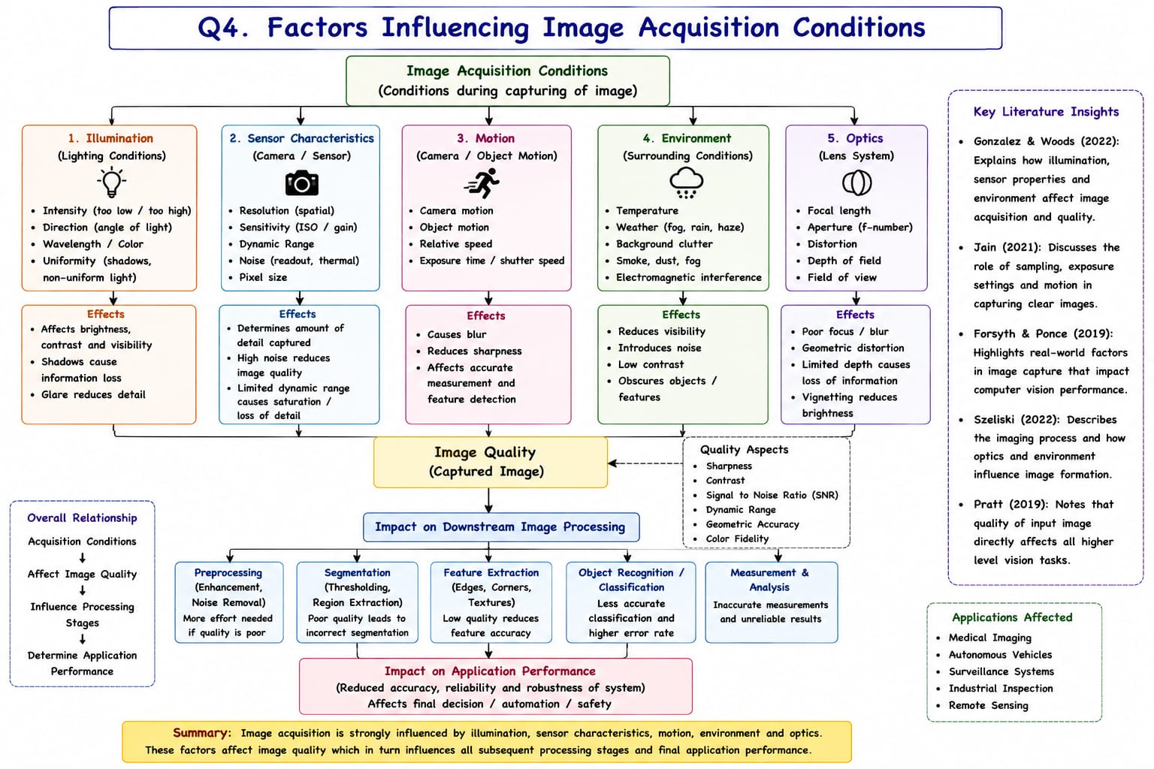

Acquisition Conditions Concept Map (Q4)

Acquisition Factor Vector | Primary Phenomenon Details | Downstream Consequences
Illumination & Optics Vectors | Define lighting uniformity, focus precision, and exposure metrics. | Directly shape raw sharpness and contrast; bad conditions blur features or saturate sensors.
Sensor & Environmental Vectors | Introduce thermal/readout noise, atmospheric light scattering. | Lowers Signal-to-Noise Ratio (SNR), necessitating complex filtering stages down the pipeline.
Downstream Process Impact | Corrupts data structural integrity at the earliest stage. | Forces heavy preprocessing, breaks segmentation thresholds, and degrades final measurement reliability.

Literature Insights & Evidence (Q4)
• Gonzalez & Woods (2022): Explains how illumination, sensor properties, and environment affect image acquisition and quality.
• Jain (2021): Discusses the role of sampling, exposure settings, and motion in capturing clear images.
• Forsyth & Ponce (2019): Highlights real-world factors in image capture that impact computer vision performance.
• Szeliski (2022): Describes the imaging process and how optics and environment influence image formation.
• Pratt (2019): Notes that quality of input image directly affects all higher level vision tasks.

Q5. Relationship Between Computer Vision Capabilities and Vision-Based Applications
The engineering selection and deployment of a vision-based system are determined by matching an application's requirements with a Computer Vision system's core capabilities (Perceive -> Understand -> Decide). These core technical capabilities span the entire processing spectrum: Image Acquisition, Preprocessing, Feature Extraction, Analysis & Understanding, Learning & Adaptation (Machine/Deep Learning), and Decision & Output. A system's core execution limits directly influence high-level application effectiveness parameters: Accuracy (precise features), Robustness (handling lighting/occlusions), Efficiency (real-time processing), Reliability (consistent performance), Scalability (handling large data/complex tasks), and Usability. These capabilities guide application selection based on targeted demands: Medical Imaging mandates high accuracy and reliability for tumor and disease detection; Autonomous Vehicles demand exceptional robustness and efficiency for lane/obstacle detection and path planning; Face Recognition relies on feature accuracy and learning for identification; while Industrial Inspection requires consistent reliability for defect monitoring. Aligning specific capabilities ensures a robust real-world impact on safety, automation, productivity and decision making.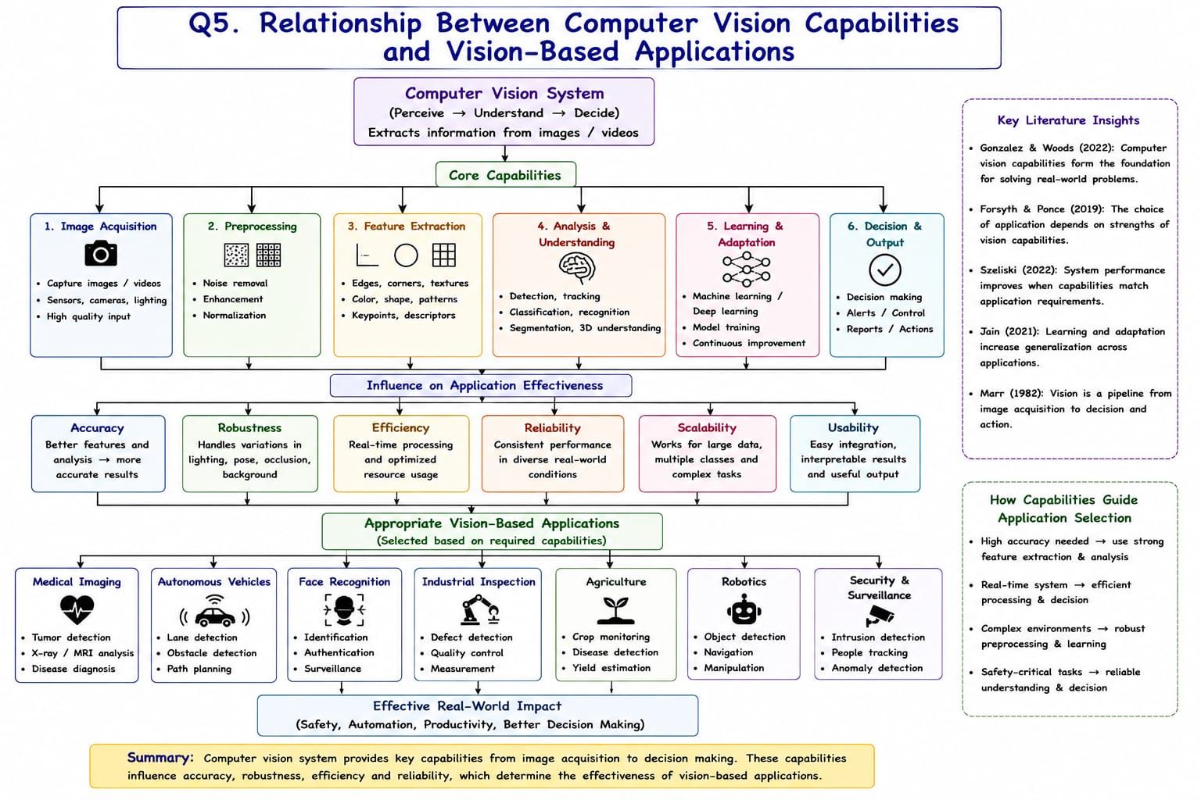

Capabilities vs Applications Architecture Map (Q5)
Core System Capability | System Effectiveness Vector | Target Vision-Based Application Domain
Core Technical Capabilities | Spans Acquisition, Preprocessing, Feature Extraction, Semantic Analysis, Learning, and Decision Output. | Acts as the foundation that dictates how well visual data is parsed.
Effectiveness Vectors | Comprises Accuracy, Robustness, Efficiency, Reliability, Scalability, and Usability. | Determines how system capabilities map onto application performance levels.
Target Application Domains | Includes Medical Imaging, Autonomous Vehicles, Face Recognition, Industrial Inspection, Agriculture, Robotics, and Surveillance. | Selected strategically based on matching necessary capability levels to domain safety/operational tasks.

Literature Insights & Evidence (Q5)
• Gonzalez & Woods (2022): Computer vision capabilities form the foundation for solving real-world problems.
• Forsyth & Ponce (2019): The choice of application depends on strengths of vision capabilities.
• Szeliski (2022): System performance improves when capabilities match application requirements.
• Jain (2021): Learning and adaptation increase generalization across applications.
• Marr (1982): Vision is a pipeline from image acquisition to decision and action.

